Feng Chia University

Electrical Engineering Fundamentals II Lab

Laboratory 8

OPAmp-Summer and Difference Amplifiers

Instructor: Prof. Shyan-Lung Lin

Student Name: 周嘉禾

Student ID: D1166506

Experiment Date:02/05/2024

1. Introduction
2. To observe the behavior of Op Amp in summer and difference amplifiers
3. Materials
   1. Power supply
   2. Digital Multimeter
   3. Function generator
   4. Devices

OPAmp: μA741

Resistors: R = 1kΩ×4, 2kΩ×2, 30kΩ×1, 10kΩ×4, 20kΩ×2, 100kΩ×2

Variable Resistor: 5 kΩ×2

1. Circuit diagram

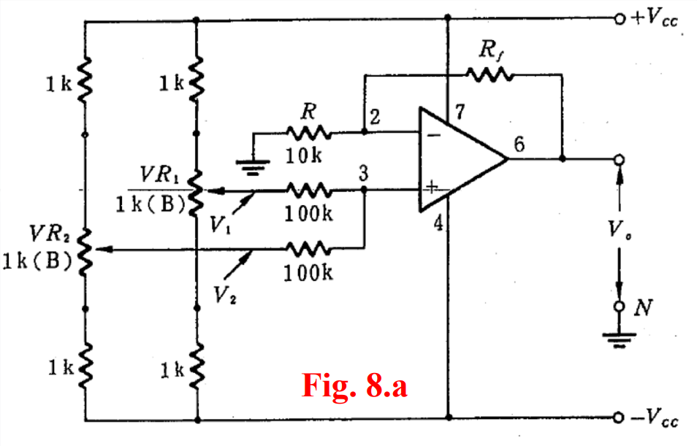

▲ Figure 1. Circuit of Experiment 8.a The Summer Amplifier

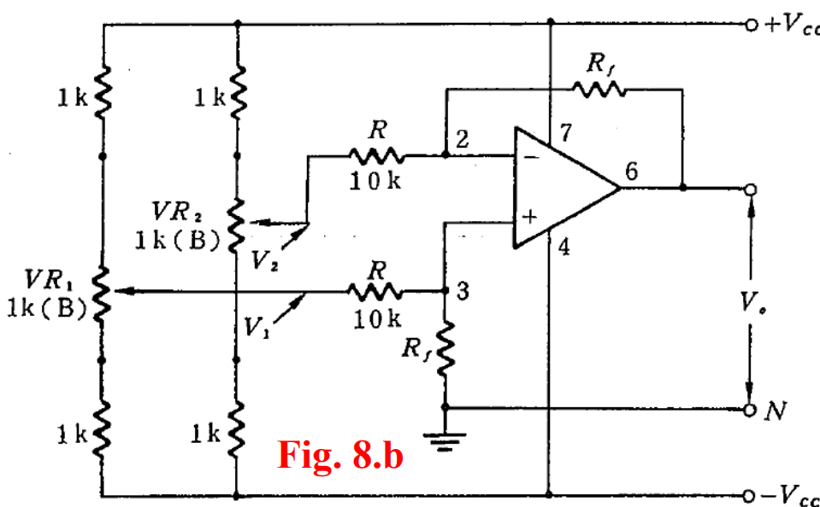

▲ Figure 2. Circuit of Experiment 8.b The Difference Amplifier

1. Methods

Using Digital Multimeter to observe voltage.

1. Experiments data
   1. Experiment 8.a The Summer Amplifier

Table 1: Measurement of output voltages VO with summer amplifiers

|  |  |  |  |  |  |  |  |  |  |  |
| --- | --- | --- | --- | --- | --- | --- | --- | --- | --- | --- |
| V1 | | -2 V | | | 0 V | 1 V | -2 V | | | |
| V2 | | 2 V | 1 V | 0 V | 1 V | 1 V | 1 V | 0 V | -1 V | -2 V |
| Rf=  30kΩ | VO | -0.0256 V | -2.0284 V | -4.0072 V | 1.9716 V | 3.9926 V | 6.0675 V | 3.9514 V | 2.0247 V | 0.0394 V |
| Gain |  | 2.0284 V | 2.0036 V | 1.9716 V | 1.9963 V | 2.0225 V | 1.9757 V | 2.0247 V |  |
| Rf=  10kΩ | VO | -0.0136 V | -1.0151 V | -2.0101 V | 1.0011 V | 1.9946 V | 3.0384 V | 1.9862 V | 1.0151 V | 0.0293 V |
| Gain |  | 1.0151 V | 1.0051 V | 1.0011 V | 0.9973 V | 1.0128 V | 0.9931 V | 1.0151 V |  |

* 1. Experiment 8.b The Difference Amplifier

Table 2: Measurement of output voltages VO with difference amplifiers

and Rf=20kΩ

|  |  |  |  |  |  |  |  |  |  |
| --- | --- | --- | --- | --- | --- | --- | --- | --- | --- |
| V1 | | 2 V | | | | | 1 V | 0 V | -1 V |
| V2 | | 2 V | 1 V | 0 V | -0.5 V | -1 V | 2 V | 2 V | 1 V |
| Rf=  20kΩ | VO | -0.0474 V | 2.1296 V | 4.0524 V | 5.1556 V | 6.0052 V | -1.9346 V | -3.9692 V | -4.1584 V |
| Gain |  | 2.1296 V | 2.0262 V | 2.0622 V | 2.0017 V | 1.9346 V | 1.9846 V | 2.0792 V |

Table 3: Measurement of output voltages VO with difference amplifiers

and Rf=30kΩ

|  |  |  |  |  |  |  |  |  |  |
| --- | --- | --- | --- | --- | --- | --- | --- | --- | --- |
| V1 | | 2 V | | | | | 1 V | 0 V | -1 V |
| V2 | | 2 V | 1 V | 0 V | -1 V | -2 V | 2 V | | |
| Rf=  30kΩ | VO | 0.0351 V | 1.0788 V | 2.0524 V | 3.0424 V | 4.0756 V | -0.9806 V | -2.0115 V | -2.9441 V |
| Gain |  | 1.0788 V | 1.0262 V | 1.0141 V | 1.0189 V | 0.9806 V | 1.0058 V | 0.9814 V |

1. Results

None

1. Discussion

The Vo and gain of Op Amp with summer and difference amplifiers will vary with the resistors.

1. Conclusion

From the experimental data above, the operational amplifiers work in an ideal situation.